**Project Development Phase**

**Model Performance Test**

|  |  |
| --- | --- |
| Date | 10 November 2022 |
| Team ID | PNT2022TMID27450 |
| Project Name | Project – Handwritten Digit Recognition System |
| Maximum Marks | 10 Marks |

**Model Performance Testing:**

Project team shall fill the following information in model performance testing template.

**MODEL SUMMARY**

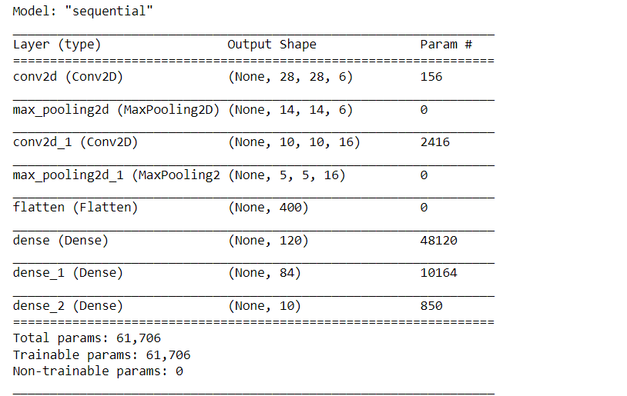

**ACCURACY**

|  |  |
| --- | --- |
| Training Accuracy | 99.2 % |
| Validation Accuracy | 99.8 % |
| Epochs Trained | 200 |

**TRAINING PLOT**

